Bridge Passer

**Test 1**

**Date:** 2021/03/24

**Tester:** Lide Cui

**Author:** Lide Cui

**Hardware version:** 1.3 (in Part 2.5 of [Hardware Document](https://docs.google.com/document/d/11jkA_S_xBqyCbcn2NyMuM-OMDEybDfRy/edit#))

**Software version:** 1.4 (in Part 7.0 of [Software Document](https://docs.google.com/document/d/19JaY5629aUu4Y4rjoQJ-jWyeQLqNSAcr/edit))

**Test Purpose:** Test the compatibility of the robot localize the position of the bridge and across it.

**Test Procedure:** Place the robot at the position where localization is completed ((1,8) or (13, 8)). The robot will run the bridge passer method to first calculate the start and end location of the bridge. And run a travers method to arrive at the other side of the bridge.

**Test Data/Result :**

|  |  |
| --- | --- |
| Test Inputs TNR_UR, TNR_LL | Outputs |
| TNR_LL (0, 5) TNR_UR (1, 7) | Success |
| TNR_LL (2, 7) TNR_UR (4, 8) | Success |
| TNR_LL (11, 7) TNR_UR (13, 8) | Success |
| TNR_LL (14, 5) TNR_UR (15, 7) | Success |
| TNR_LL (1, 2) TNR_UR (2, 4) | Success |
| TNR_LL (2, 2) TNR_UR (3, 3) | Fail (robot cannot identify correct start location) |

**Expected Result:**

The robot should correctly identify the start and end point of the bridge and across

**Test Report:**

After doing tests, we find that the robot can correctly identify the correct location to start and end the bridge crossing. However, at a certain position and the length of the bridge is 1, the robot cannot identify the correct midpoint across the bridge.

**Conclusion:** This method can satisfy our requirements most of the time. However, it may fail at some corner cases.

**Action:** A possible solution would be to compare the location of two candidates, the one that is on the edge of the island is selected as start, which indicates the point on the opposite edge is selected as the end point, for the points will be next to the sea.

**Distribution:** Software Development

**Test 2**

**Date:** 2021/4/5

**Tester:** Junjian Chen

**Author:** Junjian Chen

**Hardware version:** 1.3 (in Part 2.5 of [Hardware Document](https://docs.google.com/document/d/11jkA_S_xBqyCbcn2NyMuM-OMDEybDfRy/edit#))

**Software version:** 1.8 (in Part 7.0 of [Software Document](https://docs.google.com/document/d/19JaY5629aUu4Y4rjoQJ-jWyeQLqNSAcr/edit))

**Test Purpose:**

Test the compatibility of the robot localize the position of the bridge and across it.

**Test Procedure:**

Place the robot at the position where localization is completed in the red or green corner. The robot will run the bridge passer method to first calculate the start and end location of the bridge. And run a travers method to arrive at the other side of the bridge.

**Test Data:**

Testing Map1:

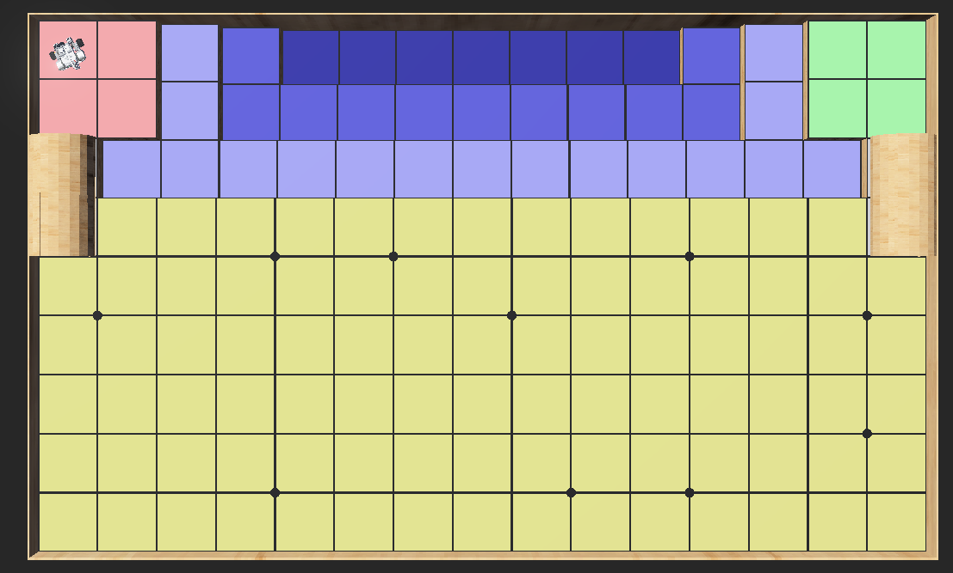

Testing Map2:

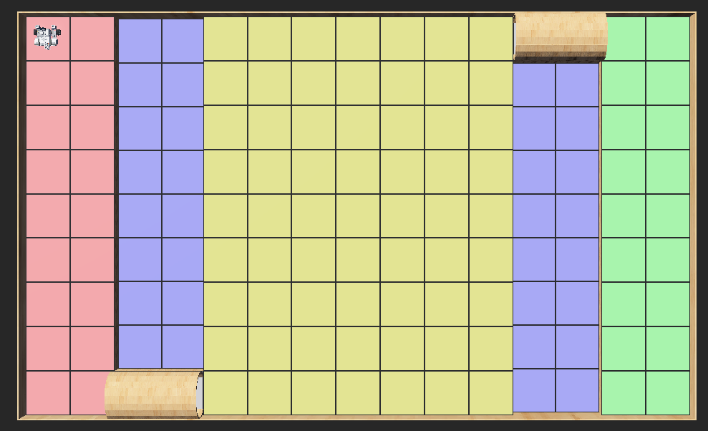

Map1:

|  |  |
| --- | --- |
| Trial# | Team Color |
| 1-5 | RED |
| 6-10 | GREEN |

Map2:

|  |  |
| --- | --- |
| Trial# | Team Color |
| 1-5 | RED |
| 6-10 | GREEN |

**Expected Result:**

The robot is expected to pass the tunnel by navigating through waypoints in this sequence: pre-start point->start point->end point->pre-end point.

Map 1:

|  |  |  |  |  |  |  |
| --- | --- | --- | --- | --- | --- | --- |
| Trial# | Team Color | pre-start point | start point | end point | pre-end point | Pass |
| 1 | RED | (0.5,7.5) | (0.5,7) | (0.5,5) | (0.5,4.5) | Pass |
| 2 | GREEN | (14.5, 7.5) | (14.5, 7) | (14.5, 5) | (14.5, 4.5) | Pass |

Map2:

|  |  |  |  |  |  |  |
| --- | --- | --- | --- | --- | --- | --- |
| Trial# | Team Color | pre-start point | start point | end point | pre-end point | Pass |
| 1 | RED | (1.5, 0.5) | (2, 0.5) | (4, 0.5) | (4.5, 0.5) | Pass |
| 2 | GREEN | (13.5, 8.5) | (13, 8.5) | (10.5, 8.5) | (11, 8.5) | Pass |

**Test Results:**

Map1:

|  |  |  |  |
| --- | --- | --- | --- |
| Trial# | All Points are calculated correctly | Pass the tunnel successfully | Comment |
| 1 | Yes | Yes |  |
| 2 | Yes | Yes |  |
| 3 | Yes | Yes |  |
| 4 | Yes | Yes |  |
| 5 | Yes | Yes |  |
| 6 | Yes | Yes |  |
| 7 | Yes | Yes |  |
| 8 | Yes | Yes |  |
| 9 | Yes | Yes |  |
| 10 | Yes | Yes |  |

Map2:

|  |  |  |  |
| --- | --- | --- | --- |
| Trial# | All Points are calculated correctly | Pass the tunnel successfully | Comment |
| 1 | Yes | Yes |  |
| 2 | Yes | Yes |  |
| 3 | Yes | Yes |  |
| 4 | Yes | Yes | The robot rubs to the edge of the tunnel when passing. |
| 5 | Yes | Yes |  |
| 6 | Yes | Yes |  |
| 7 | Yes | Yes |  |
| 8 | Yes | Yes | The robot rubs to the edge of the tunnel when passing. |
| 9 | Yes | Yes |  |
| 10 | Yes | Yes | The robot rubs to the edge of the tunnel when passing. |

**Test Report:**

Pass Rate:100%

In both Map 1 and 2, the algorithm calculated the needed points to pass the tunnel correctly. All of the trials pass the tunnel successfully. **However**, in 3 trials of the Map2 test, the robot rubs to the edge of the tunnel when passing. This is because the pre-start point is far from the starting point after localization. Large errors exist after traveling for a long distance so the angle of the robot is not accurate when passing the tunnel, causing it to rub to the edge. Although it passes the tunnel, it may affect the navigation after it.

**Conclusion:** Conditional Pass.If the starting position is closed to the pre-start point, the robot can pass the tunnel successfully. If the starting position is far from the pre-start point, the robot can pass this unit test but still need improvement.

**Action:** Add some angle correction when the robot travels to the pre-start point.

**Distribution:** Software Development

**Test 3**

**Date:** 2021/4/10

**Tester:** Junjian Chen

**Author:** Junjian Chen

**Hardware version:** 1.5 (in Part 2.5 of [Hardware Document](https://docs.google.com/document/d/11jkA_S_xBqyCbcn2NyMuM-OMDEybDfRy/edit#))

**Software version:** 2.2 (in Part 7.0 of [Software Document](https://docs.google.com/document/d/19JaY5629aUu4Y4rjoQJ-jWyeQLqNSAcr/edit))

**Test Purpose:** Test whether the new algorithm could calculate the coordinate of the “After-Tunnel-Localization Point” which is “tnLocalizationPoint” in the code. And also tests whether the robot is able to localize it correctly.

**Test Procedure:**

1. Place the robot on the position where ultrasonic and light localization are finish
2. Use the “acrossBridge()” method to cross the tunnel
3. Use the “smallDistanceLocalization(tnLocalizationPoint)” method to move to the “After-Tunnel-Localization Point”
4. Observe and record in which process the robot passes or fail
5. Repeat each trial for 5 times

**Test Data:**

Map for Trial 1-5,6-10:

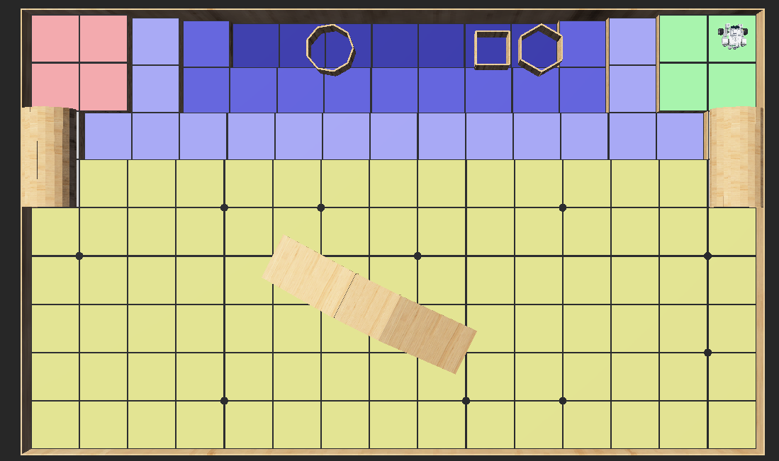

Map for Test 11-15,15-20:

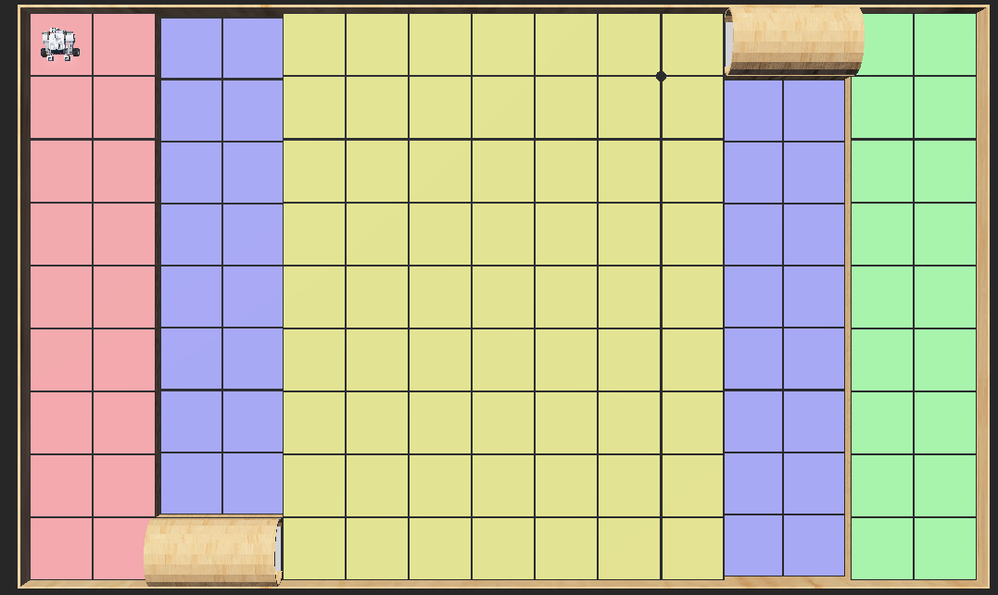

**Expected Result:**

The robot is able to calculate and navigate to the correct “After-Tunnel-Localization Point”.

|  |  |  |
| --- | --- | --- |
| Trial# | Expected Path | Expected Scenario |
| 1 | Figure 3.1 The planned path of passing the tunnel of trial 1 | 1. The robot starts at (1,8) 2. The robot navigates to (1.5,0.5) 3. The robot passes the tunnel and get (4.5,0.5) 4. The robot calculates that “After-Tunnel-Localization Point” is (5,1) 5. The robot localizes to (5,1) |
| 2 | Figure 3.2 The planned path of passing the tunnel of trial 2 | 1. The robot starts at (14,1) 2. The robot navigates to (13.5, 8.5) 3. The robot passes the tunnel and get (10.5,8.5) 4. The robot calculates that “After-Tunnel-Localization Point” is (10,8) 5. The robot localizes to (10,8) |
| 3 | Figure 3.3 The planned path of passing the tunnel of trial 3 | 1. The robot starts at (1,8) 2. The robot navigates to (0.5,7.5) 3. The robot passes the tunnel and get (0.5,4.5) 4. The robot calculates that “After-Tunnel-Localization Point” is (1,4) 5. The robot localizes to (1,4) |
| 4 | Figure 3.4 The planned path of passing the tunnel of trial 4 | 1. The robot starts at (14,8) 2. The robot navigates to (14.5,7.5) 3. The robot passes the tunnel and get (14.5, 4.5) 4. The robot calculates that “After-Tunnel-Localization Point” is (14,4) 5. The robot localizes to (14,4) |

**Test Results:**

|  |  |  |
| --- | --- | --- |
| Trial# | Pass/Fail | Comment |
| 1-5 | P/P/P/P/P |  |
| 6-10 | P/P/P/P/P |  |
| 11-15 | P/P/P/P/P |  |
| 16-20 | P/P/P/P/P |  |

**Test Report:**

Pass Rate:100%.

All trials pass the test. “After-Tunnel-Localization Points” are calculated correctly and the robot localizes them perfectly.

**Conclusion:** The test passes.

**Action:** None

**Distribution:** Software Development